*noslegal*

Taxonomy release notes

**Release 2.0 / 8 May 2023**

This document is to explain the ‘why’ and ‘what’ of our May 2023 release, plus a bit of ‘how’ for those interested in such things.

It can be read on its own, but for you may also be interested in the [March 2022 notes](https://github.com/noslegal/taxonomy/blob/main/2022.03.31-noslegal-release-notes-taxonomy.md) which accompanied release 1.0.

* As those 2022 notes indicate, the **Places** facet of our taxonomy was largely quite mature at that stage.
* Some [incremental updates](https://github.com/noslegal/taxonomy/blob/main/2022.11.05%20noslegal%20legal%20places%20release%20notes.md) to Places followed in November 2022. Some more incremental updates to Places are following now, in May 2023, described below.

The main content of this new release consists of significant developments in facets of our work which were much less mature in March 2022.

The March 2022 release included three facets called **Work**, **Subjects** and **Perspectives**. The rest of this document expands on how we have developed those and also addressed further topics in four further facets, namely, **Needs, Sectors, Laws, Information Assets** and **Combinations**.

Two other new points to highlight about this release are

* **New formats:** We are making the taxonomy content available in JSON and CSV as well as Excel.
* **Implementation:** We are also publishing a new slide deck covering what noslegal is all about and suggested approaches to implementing it in a law firm.

Without repeating the March 2022 release, this document offers (1) a short introduction, (2) detailed notes on the contents of this release and (3) an indication of what we propose to do next.

There are two appendices, covering (1) detailed updates to Places (2) our study of options for a sectoral taxonomy

This release has been approached as a community effort. Thank you to all contributors, who include, in alphabetical order: Richard Batstone, Jacob Capleton, Sarah Charig, Sam Grange, Graeme Johnston, Alice Laird, Mischka Manan, Paul McCormack, Molly MacGregor, Marius Manole, Marco Mendola, James Pilgrim, Lewis Quinn, Kara Redmond, Nandana Santhosh, Joanna Schmidt, Katy Snell and Antony Smith.

# INTRODUCTION

**Needs addressed:** We’ve been developing a taxonomy suitable for practical needs in organisations which handle legal matters.[1] Those needs are mainly in:

(1) practical knowledge and systems

(2) work, process and financial

(3) sales and marketing

(4) people and organisation

These needs are mainly felt by people and organisations doing and commissioning law-related work (e.g. law firms, legal departments, ALSPs[2]) and providers of software used in such work.

Our taxonomy is intended to be relevant across these four broad needs, though of course the relevance of particular parts will be more or less intense depending on the context. Historically, the needs have tended to be addressed by separate taxonomies, which has hampered a joined-up approach to important issues.

We’re not seeking to address legal education and research (e.g. case law) needs as they risk impairing the other needs by excessive legal-conceptual detail.

**Key principles:**

(i) simplicity of core content - limited number of facets, with only a few levels and concepts in the core,

(ii) extensibility - niche details are addressed in extension packs,

(iii) modular - given different preferences and priorities between and within organisations, and differing needs and opinions between places and over time, we have designed with a view to those differences being accommodated primarily by combination of simple elements,

(iv)system-neutrality- we’ve sought to make it as internationally relevant as we can rather than building upon the conceptualisations of just one legal system or system-family (e.g. common law),

(v) practical - distinctions made based on what we’ve found to be important,

(vi)‘design-led’ and ‘data-informed’ rather than ‘data-driven’ - we’ve looked at a lot of taxonomies, public and private. We’ve also spoken with a lot of people about the problems they’ve encountered and the needs they’re seeking to address. But we’ve used our judgement as to what to make of all this,

(vii) more attention is given to synonyms and examples than to perfect definitions - although we have sought to avoid gaps and overlaps, we are conscious of some and have decided to put it out there anyway and improve it over time.

**Overview of content:** This taxonomy release has nine facets:

| **Places** | *countries, subdivisions and related information* |
| --- | --- |
| **Needs** | *as this topic is fundamental, we decided to taxonomise it, though we doubt it will be incorporated in systems in the same way as other facets* |
| **Work** | *legal work as a process (e.g. litigating, transacting)* |
| **Subjects** | *the* *‘nouns’ of legal work - e.g. people, things, obligations* |
| **Perspectives** | *personal, business, state and social needs and issues* |
| **Sectors** | *we’ve based this around the NACE 2.1 taxonomy but with some simplifications, adjustments and extensions* |
| **Laws** | *areas of law and regulation not naturally covered by the above facets* |
| **Information assets** | *documents, their parts and other information assets* |
| **Combinations** | *examples of concepts made by combining simple concepts from the other facets (for instance, ‘insurance regulatory investigations’ is expressed as a combination of elements from sectors (insurance), laws (regulatory) and work (investigations).* |

**Comparison with the March 2022 release:**

* Work, Places, Subjects and Perspectives have largely the same structure as in March 2022, though some adjustments of detail have been made.
* We have split everything into **core and extension packs (XPs)**: the idea here is to allow for quick assessment and adoption of the fairly simple cores, with organisations then picking and choosing among XPs depending on relevance.
* Sectors and Laws are new, and include some elements previously in Perspectives.
* Information assets is new and at this stage very light - future extension packs may tackle topics in which interest has been expressed, such as contracts and litigation documents.
* Combinations is different from the other facets, in that it consists simply of combinations of concepts from those facets. The combinations given are just illustrative, and we will likely develop more. We welcome contributions.

# DETAILED DISCUSSION

This section covers six topics

1. Design strategy
2. Technical formats
3. Differences from typical current approaches
4. Adopting and migrating to noslegal
5. Facet-by-facet notes
6. Overlaps and ambiguities

## A. Design strategy

Each of the main facets (i.e. except ‘Needs’ and ‘Combinations’) should

1. **have a ‘core’ containing some fairly simple content**, readily digestible and relevant to most legal systems and many organisations,
2. be **extensible** to cover topics of national, sub-national, system-type, sectoral, org-specific or other specialist relevance,
3. be **combinable** to express the sorts of hybrid concepts which law firms and other organisations often adopt in order to describe niche areas of work which are economically or otherwise significant for them,
4. be structured as **simple trees and flat lists** with recommendations on how to use them,

The following pages expand on these points.

### (1) Cores

* The cores should be tightly designed and editedso as to constrain them to a digestible size. This is also important to ensure and maintain high quality definitions, synonyms and examples, and to reduce ambiguity, overlap, gaps and scope creep. That said, we have not sought to squeeze out all ambiguity, overlap and gaps as we think it is better to put it out there with a little looseness at this stage then tighten up later based on experience.
* There is inevitably some subjectivity in this field, so a strong design and editorial control - with insight into broad needs and alive to the risks of over-fitting - are particularly important.

### (2) Extensions

* We have developed some initial ‘extension packs’ within noslegal for each facet to cover things that will likely only be of interest to particular groups.
* These include different dimensions of a topic addressed in the ‘core.’ For example, basic types of ‘person’ (e.g. individual, corporate body) are part of the core of the Subjects facet, but the ‘roles’ (e.g. buyer, defendant) which persons may have is covered in an extension pack.
* Extension packs may also elaborate on an existing concept in the ‘core’ - for example, the core concept of ‘corporate body’ may be elaborated upon to capture the different types of corporate body encountered in a particular legal system or context. We’ve included in this release such an extension pack for the UK.
* In line with the permissive open source ethos of noslegal, anyone should be free to develop such ‘extension packs,’ to keep them private or to publish them on whatever terms (including non-open source terms e.g. CC-BY-ND or ‘super’-open source terms e.g. CC-SA).
* We propose to develop a system for reviewing and endorsing community-developed packs which meet various minimum standards for maintaining such endorsement. These should include considerations of quality, completeness and process (e.g. commitment to periodic reviews). Let us know if you’d like to be involved as a provider or reviewer of such material.

### (3) Combinations

* ‘Atoms’ or ‘components’ from each of the seven main facets can be combined to create more complex ‘molecules’ in whatever combinations an organisation needs. This is key to allow flexibility to meet different needs within and between organisations.
* We should provide guidance and examples of how to do this, including cautionary notes as to overlaps and alternative ways of combining concepts.
* It should be possible to subdivide combinations. For example, ‘Financial Services’ (from Sectors) could be combined with ‘Investigations’ (from Work) to define ‘Financial Services Investigations.’ A subtype of this might be ‘Insurance Investigations.’

### 

### (4) Structure

* There should be no more than three (ideally) levels in each facet’s core content, with the upper levels each only containing a handful of concepts.
* Each concept should where relevant have definitions, synonyms, examples. In some cases, other metadata may also be relevant. These should be regularly reviewed and updated, with some effective strategies for doing so effectively.[3]
* We will **not** initially be developing a full **ontology** in [the more sophisticated sense](https://en.wikipedia.org/wiki/Ontology_(computer_science)) (i.e. defining nodes and edges in ways that go beyond simple trees, flat lists and sets of properties). This is a strategic decision intended to make it usable in as wide a range of systems as possible (including recommendations for how to concatenate concepts for use in systems which only support flat tags, or limited levels of hierarchy).
* For those with more sophisticated software systems, the taxonomies can be extended or converted over time into more expressive ontologies. However, maintaining and extending such extended versions will not be undertaken by the taxonomy content working group initially. Its development will depend upon appetite to do this extra work by organisations having relevant systems.

## B. Technical formats

Based on demand from participating organisations, we have released in Excel (to ensure readability for non-technical users) but with JSON and CSV versions for technical applications. Two major participating organisations (Herbert Smith Freehills and iManage) have kindly handled the conversion into JSON and CSV.

We are open to suggestions for further formats. At this stage we are not planning to support a Protege version or semantic web format as we do not have demand for this among participating organisations. But in line with our permissive open source ethos, others are free to do so, and please let us know if you would like to collaborate on this (e.g. to make such a version available through our channels).

## C. Differences from typical current approaches

Our approach is different from the typical legal industry approach at present.

These typically

* organise primarily around a particular national legal system, the concepts of which often don’t apply outside that context,
* mix up sectors, process types, legal issues, places and more,
* give the impression of having been created according to what seemed plausible for a particular purpose (at best, one of the needs identified at the start of this paper, but often even narrower) at a particular time, without a robust design strategy,
* are difficult to apply,
* are often siloed in particular parts of an organisation e.g. with knowledge management, marketing, process improvement, legal and business functions doing their own things,
* are largely bespoke and suffer from problems of quality, conceptual overload, gaps and relevance, which become worse over time - almost inevitably, given the huge time and therefore cost required to do these things effectively,
* are practically impossible to map in a truly effective and up to date way, between organisations or even within an organisation - inevitably, given the number of targets and their moving nature.

In short, the quality, relevance and value are too low and the cost is too high.

Our suggested approach seeks to reduce cost per organisation (by sharing the effort on topics of common interest) while achieving better quality, relevance and value. We do so by

* an overall design which is not tightly coupled to a single national legal system, or family of systems,
* addresses quality, irrelevance, conceptual overload, cost and maintenance challenges by collaboration and an emphasis on simplicity and fitness for purpose,
* emphasising modularity and combination concepts allow for divergence between the needs arising in different organisations, contexts (e.g. financial reporting, process improvement, knowledge management, marketing) and times - even if the combinations adopted in each are different. Combinations should still be approached thoughtfully, as they could also be allowed to become over-complicated. But they do allow for flexibility in thoughtful hands.

## D. Adopting and migrating to noslegal

As part of the May 2023 release, we’re providing a separate slide deck addressing practical topics. Depending on appetite (please let us know if you’re interested in collaborating on this), we anticipate possibly issuing further material over time on topics such as

* **Identifying needs** within an organisation, now and for potential futures.
* **Analysing** how well existing taxonomies in use meet those needs, and the causes of any shortfalls.
* **Considering** **which elements** of noslegal taxonomy materials can meet those needs, and any extensions and combinations required - whether privately or as a proposed noslegal project.
* **Assessing technically and in terms of business process and design** how to implement it in the organisation’s systems - a key risk here being in ending up with junk data.
* **Assessing the extent to which it is useful to map to legacy taxonomies and legacy data -** bearing in mind that there will be conceptual and data quality issues. Then - to the extent useful - doing the **mapping.**
* **Deciding how to implement, test, maintain and improve the approach.**

## E. Facet-by-facet summary

## 

### Places

This is substantively unchanged since the March 2022 release except for minor updates made in November 2022. In line with our broader strategy of separating content into cores and extension packs, we have moved these elements into extension packs:

* Legal systems
* Connecting factors
* Conventions, organisations and memberships

We have also made various substantive updates - see **Appendix 1** for details.

### Needs

This simply contains, with definitions, the major needs addressed by noslegal:

* Knowledge and Systems
* Work, Process and Financial
* Sales and Marketing
* People and Organisations

We have at this stage left these needs at a deliberately high level. They can certainly be broken down further. We could also in principle add different dimensions e.g. software systems for addressing particular needs. We would welcome suggestions.

### Work

The March 2022 release had three top-level types:

* Resolving
* Transacting
* Operating

These are retained in the new release - we have not prepared any extension packs but have offered combinations (see below) relying on elements from Work. We will likely develop further extensions or combination for types of process in locales or other specialised contexts, such as types of litigation or financing.

### Subjects

The three top-level types are essentially the same[4] as the March 2022 release, with some terminological change:

* Person (renamed from ‘People’)
* Property
* Obligation (renamed from ‘Duties’)

We have made some changes of detail, most notably to

* create a concept of organisation within person, as an aggregation of corporate body, unincorporate body and authority
* elaborate Obligation to a third level, while staying quite simple
* improved some definitions and added some synonyms and examples

We have also put together four extension packs based on demand from partaking organisations.

* **Person roles:** roles which Persons can have in relation to work or documents, including indications of the kinds of subject that they can apply to, some groupings (e.g. buyer/seller), synonyms (some of which are process/place-specific) and some ‘soft’ (i.e. likely but not rigid) associations (e.g. buyer with transacting).
* **Subject connectors:** relationships which can exist between persons and other types of subject.
* **Features:** Miscellaneous characteristics of Persons in addition to their primary taxonomisation. There are four groups initially:
  + Commercial features (e.g. business, not for profit)
  + Organisation size features (e.g. SME)
  + Common interest features (e.g. industry body)
  + Individual features (e.g. HNWI)
* **UK corporate and unincorporated body types:** if found useful, we would welcome similar contributions from other jurisdictions. We are inclined to do this at country level, at least in the near future, as the differences between similarly-named bodies can be quite treacherous.

### 

### Perspectives

The March 2022 release had three top-level types:

* Personal Life
* Business
* Society and Authority

We have maintained these, with some refinement of the numbering scheme and of details at the lower levels - removing ‘Regulation’ and adding ‘Sovereign debt.’

We are conscious that there is some potential for overlap between two new facets (**Sectors** and **Laws**) and **Perspectives**. We have not sought to resolve that fully at this stage, but will do so over time, depending on use and feedback.

### Sectors

Having reviewed a large number of sectoral taxonomies used in the legal world, our impression is that the most relevant are those developed by law firm marketing teams and exposed on their websites. These are typically more carefully designed than the taxonomies we have seen from less outward-facing groups in law firms, presumably reflecting the more pressing relevance of this topic for outward-facing purposes. The fact that those website taxonomies are by definition publicly available has made it possible for us to review a large number and identify their common and divergent aspects.

In producing a single standard, we have decided to take the February 2023 release of Revision 2.1 of the NACE taxonomy as our starting point. Many elements of this map well to what law firms are doing already. But we have offered some extensions, reorganisations and aggregations relevant to legal work, taking account of the law firm taxonomies we have reviewed.

* Part of our work there reflects the reality that people conceptualise the modern economy in certain contexts (e.g. financial services and software) differently from how it is conceptualised in NACE 2.1 and similar taxonomies.
* We have adjusted the level of detail exposed in the core noslegal taxonomy to reflect what we have found to be of interest in legal work. This has involved reducing, for example, the large number of manufacturing subdivisions contained in NACE 2.1, though these are preserved in an extension pack for those who wish to choose at least some of them.

We think this hybrid strategy offers the best combination of benefiting from existing work in a way that is widely relevant internationally and well-fitted to legal work. We recognise that different organisations will choose to expose different elements to their clients and internal people, and that is fine, as the mapping will still work so far as two organisations (or one organisation over time) choose the same concepts.

This was a particularly complex topic, and we have summarised our review in detail in the appendix to this paper.

However, by way of overview, we have adopted 15 top-level categories in the core taxonomy

1. Agriculture
2. Natural resources
3. Manufacturing
4. Energy supply
5. Water
6. Construction
7. Trade
8. Transport services
9. Hospitality services
10. Information services
11. Financial services
12. Real estate
13. Education
14. Care
15. Other services

Most of these follow NACE 2.1, but we have renamed many of them to use more modern and succinct terminology. We have also made some significant changes of detail based on our conclusions as to relevance to legal services, supported by our review of many law firm taxonomies:

1. We have not subdivided **Agriculture** in the core, but the three NACE 2.1 divisions (farming, forestry and fishing) are available in an extension pack.
2. We have consolidated **Natural resources** into two divisions within the core: mining (which in NACE 2.1 is four divisions) and upstream oil and gas (only one division in NACE 2.1. We have renamed it to reflect more familiar and succinct terminology).
3. We have included some NACE 2.1 divisions in **Manufacturing** within the core, but relegated others to an extension pack where not widely encountered in law firm taxonomies. We have also amalgamated some divisions, and added a non-NACE 2.1 subdivision (fashion) found convenient in some law firms.
4. In **Energy supply**, we have adopted in core the two NACE 2.1 subdivisions which we think are most relevant in law firms: electricity and gas, with renewable electricity as a subtype of electricity.
5. We have left **Water** undivided, as this is commonly the approach in law firms. NACE 2.1 offers some divisions which can be used if required.
6. In **Construction**, we have followed NACE 2.1 in dividing this into building and infrastructure. These may be subdivided further if required.
7. We have also followed NACE 2.1 on **Trade** by simply dividing it into wholesale and retail.
8. In **Transport services**, we have followed NACE 2.1 but reordered and renamed the divisions to reflect what appears to be most relevant in law firms.
9. **Hospitality services** comprises what NACE 2.1 calls Accommodation and Food Service Activities - hotels, restaurants, bars and also services of the AirBnB type.
10. **Information services** is a significant reworking by us, aggregating NACE 2.1 sections J (content industry), K (telecoms, software and other information services) and S (arts, sports and recreation, including gambling). We have done this because we think the blurring of activity in these area makes it convenient to consolidate them then subdivide into five types: software and data, content, telecoms, sport and gambling. This does involve a slight awkwardness bringing the ‘in person’ elements from S (e.g. theatre, sports events, gyms) but it seems appropriate overall given the extent to which the legal work in relation to such activities is in relation to the complexities involved in their online aspects.
11. We have significantly reworked the elements of the **financial services** to reflect what we have found to be of relevance to law firms.
    1. We have six main subdivisions.
       1. Three of these (insurance, pension funds, investment funds) follow NACE 2.1, with some internal reorganisation.
       2. The other three (banking, financial markets, private wealth) are given more prominence by us than in NACE 2.1 given their significant in modern financial services and associated legal services..
    2. We have broken down four of these six elements further in an extension pack, relying mainly on our review of law firm and other market usage rather than on NACE 2.1.
12. We have subdivided **real estate** primarily by the type of property (e.g. commercial or residential) as we believe this is more relevant in legal services than NACE 2.1’s approach of doing so primarily by type of transaction (e.g. buying or leasing).
13. **Education** follows NACE 2.1 and we have not subdivided it.
14. **Care** also follows NACE 2.1, with two subdivisions: health and social care.
15. We have also broken down **other services** (in an extension pack) to highlight particular types (e.g. lawyers, accountants) in which some law firms specialise. This can be further subdivided if required, possibly to cover common forms of outsourcing.

The first extension pack contains further subtypes for

* **Agriculture** - the three NACE divisions
* **Manufacturing** - the NACE divisions not included in our core, but we have consolidated some
* **Financial Services** - largely new work by us based on our review of law firm taxonomies - we have not yet attempted definitions
* **Other Services** - three items selected from NACE

As sectors can be aggregated and subdivided in different ways, we have also offered a second extension pack outlining four possible alternative aggregations:

* **Energy** - upstream, midstream and downstream aspects of energy
* **Consumer goods** - production, distribution and retail of such goods
* **Mobility** - production of vehicles, infrastructure and transport services
* **Fintech** - tech used in financial services, and tech-enabled financial services

If adopting these alternatives, care should be taken to remove redundancy.

The definitions of these alternative aggregations are outlines only at this stage - we would welcome feedback on whether these are useful and, if so, how to refine their definitions. We will likely add others in future as well, and suggestions are welcome.

### Laws

This is intended to cover substantive legal and regulatory content as opposed to processes (e.g. transactions, investigations) which are applicable to different types of legal content.

The difference between an approach based around Laws and Perspectives generated a lot of discussion.

It is clear that for some technical needs (e.g. large elements of knowledge management functions), Laws is likely to be leaned upon more heavily whereas in more outward-facing areas (e.g. marketing), Perspectives will be more relevant. Many areas will involve both, and various combinations. Designing the precise balance will require some further work, much of which will best be done within specific organisational contexts. We hope that those doing so will also provide feedback on how the noslegal standard building blocks may be improved.

There is some overlap at present between Perspectives and Laws, which we intend to address over time, taking account of feedback as to how people prefer to capture these topics.

There are ten top-level categories. The first two are high level ones intended for combination with other aspects of noslegal

* Law
* Regulation

Examples of combinations using those are immigration law (immigration from Perspectives plus Law), family law (family from Subjects plus Law) and financial services regulation (financial services from Sectors plus Regulation).

The next five elements each have a domain which does not fit neatly into a single element of Perspectives, hence we have modelled them here instead:

* Economic law
* Employment law
* ESG law
* Information law

Finally, we have included three traditional legal categories which are still useful for describing legal work in a practical way:

* Criminal law
* Private law
* Public law

Most of these nine categories are broken down to a second level and in one case (intellectual property, within information) to a third level (copyright, patents etc).

We have also provided a tenth category intended for private extension to capture topics of local (e.g. Brexit) or temporary (e.g. Covid-19) interest.

* Special topics

The content of those special topics will undoubtedly vary between organisations, places and times. The purpose of providing a special location for them is to avoid temporary or local needs from interfering with topics of wider or more enduring relevance. Covid (specifically, the issues arising mainly during 2020-22) is an example of temporary need, Brexit of a longer-term but local need.

### Information assets

This is a new facet in this release.

It includes documents and we anticipate that in future it will include their parts. But as the use of information assets other than documents continues to grow (for example, interactive experiences), we think it important not to limit it to just documents. At this stage, it is fairly light, with a core containing five top-level concepts:

* Legal instrument
* Legal analysis
* Process material
* Marketing material
* Organisational material

The idea is that more than one of those may sometimes be used to describe a particular asset e.g. a legal analysis which also has value as a knowledge asset.

Knowledge asset has been broken down into six further categories: legal source, example, template, guide, training material and legal update.

We also offer three extension packs:

* One covers knowledge assets and sub-types. Although this extends the core with further subtypes, we concluded that it was best to split it out in order to emphasise that it is not mutually exclusive with the five concepts in the core. For example, a legal instrument may also be a knowledge asset.
* The other two cover different attributes of information assets:
  + Status - draft, final or fluid
  + The intended audience - for example, internal or public

In future, we envisage possible extension packs in areas such as

* Contract documents and clause types
* Litigation documents and their elements

However, these will depend on the involvement of sufficient people with expertise and availability to do the necessary work - please let us know if you are interested.

### 

### Combinations

The new release includes a short illustrative list of combinations of elements from the earlier facets.

As this is a new concept, we have limited the initial list to four main types (each with subtypes) to illustrate the idea:

* Financial regulatory (sector + law + work)
* Real estate practices (sector + work)
* Regional litigation practices (work + place)
* Corporate practices (work + work, work + subject)

Combinations are not mutually exclusive or definitive as organisations will inevitably have different needs. For that reason, organisations will also need to take responsibility for ensuring that the combinations chosen make sense for the particular purposes they’re used.

Organisations are free to develop their own combinations and to keep them private, but we would welcome proposals for further combinations to be published by noslegal.

## 

## F. Overlaps and ambiguities

We are conscious of the following issues, but have decided to leave them in the taxonomy at this stage so as to make it more feasible to test and gather feedback based on something concrete:

* Some conceptual overlap between Perspectives and Sectors / Laws.
* Alternative modelling in the roles and connector extension packs within Subjects.
* We have not sought to make the sectoral definitions exhaustive as we doubt most relevant organisations will find this useful in practice. Some difference of classification at the edges may be quite acceptable in practice. That said, we may provide further examples and other disambiguation aids.

Our general philosophy is that some overlaps and ambiguities (though not as many as now!) will likely be tolerable in the long run. In our view, it is only sensible to taxonomise law-related topics, for our chosen use cases, in a relatively simple way. Modern natural language technology can increasingly cover the metaphorical ‘last mile’ of nuance. There is a limit to what taxonomies can do, and there are some dangers inherent in excessive detail and attempts at ‘perfection.’

# NEXT STEPS

We anticipate that

* A minor release (provisionally 2.1) will follow in late 2023 containing incremental improvements to what has been released in May 2023 plus any bug fixes. So please let us have your suggestions together with any errors you identify.
* We will, in parallel to that, consider any more significant extensions. For example:
  + Contracts and litigation documents have been suggested as areas of interest to some participating organisations.
  + We are open to other ideas, including law-related topics of a non-commercial nature (we are conscious that the work to date has been largely led by commercial law firms) and regional topics (the existing extension pack on UK organisations is an example).
  + Packaging a set of public domain factual data (from World Bank and other sources) and fictitious datasets which can be used in conjunction with our taxonomy for illustrative and testing purposes and (in the case of the factual data) for mashing up with confidential or other data within organisations.

# APPENDIX 1 - LEGAL PLACES

This appendix summarises the May 2023 updates to the Legal Places taxonomy.

## Summary

# 

* This release is a minor one. It does not extend the scope of Legal Places but reflects various changes and corrections since the previous release in November 2022.
* Highlights include:
  + Updating the naming convention of parts of the Places facet to be consistent with the other facets of noslegal
  + Administrative changes of subdivisions in Iceland, Kazakhstan, Nepal and Slovenia
  + Updated the "Connecting Factors" facet, clarifying wordings and adding a "Definition" column.
  + Updates to reflect new members of various international conventions.

## Acknowledgements

This update was largely prepared by Marius Manole, with a review by Graeme Johnston.

## Details of changes

### Naming convention changes

| **New name** | **Old name** |
| --- | --- |
| Places Core - Countries and areas | LP 1.0 Countries and areas |
| Places XP1.1 - Countries - non-English names | LP 1.3 Non-Eng names |
| Places XP2.1 - Regions – UN | LP 1.1 UN regions |
| Places XP2.2 - Regions – alt | LP 1.2 Alt regions |
| Places XP3.1 - Legal systems | LP 2.0 Systems |
| Places XP3.2 - Legal system types | LP 2.1 System types |
| Places XP4.1 – Subdivisions | LP 3.0 Subdivisions |
| Places XP4.2 - Subdivision types | LP 3.1 Subdivision types |
| Places XP5.1 - Connecting factors | LP 4.0 Connecting factors |
| Places XP6.1 – Memberships | LP 5.0 Memberships |
| Places XP6.2 - Organisations and treaties | LP 5.1 Organisations and treaties |

### 

### 

### Places Core - Countries and Areas

Updated the "ISO English short name if different from noslegal name" of "Netherlands" from "Netherlands (the)" to "Netherlands (Kingdom of the)".

Updates based on <https://www.iso.org/obp/ui>

### Places XP3.1 - Legal Systems

Updated the verification links of the following as the previous ones had expired

* Åland Islands
* Korea (Republic)
* Mexico
* Türkiye
* Saint Vincent

Updates based on

<https://www.cia.gov/the-world-factbook/countries/>

<https://www.nyulawglobal.org/globalex/>

### Places XP4.1 - Subdivisions

Added the following "Provinces" under "Algeria": "Timimoun", "Bordj Badji Mokhtar", "Ouled Djellal", "Béni Abbès", "In Salah", "In Guezzam", "Touggourt", "Djanet", "El Meghaier", "El Meniaa".

Added the following "Regional State" under "Ethiopia": "Southwest Ethiopia Peoples".

Removed the "ISO Name 2" of "FI-17" ("Satakunda").

Changed the "Subdivision type" of "GB-BKM" from "Two-Tier County" to "Unitary Authority".

Removed the "GB-NTH" entry, as replaced by the addition of the following entries: "North Northamptonshire" and "West Northamptonshire".

Added the following "Provinces" under "Indonesia": "Papua Pengunungan", "Papua Selatan", and "Papua Tengah".

Removed the following entries from "Iceland": "IS-AKH", "IS-BLO", "IS-HEL", "IS-HUT", "IS-SBH", "IS-SKU", and "IS-SSF".

Added the following "Municipalities" under "Iceland": " Hunabyggo" and "Skagafjorour".

Added the following "Metropolitan City" under "Korea (North)": "Kaeseong".

Renamed the following subdivision codes under "Kazakhstan": from "KZ-ALA" to "KZ-75", "KZ-AST" to "KZ-71", "KZ-SHY" to "KZ-79", "KZ-ALM" to "KZ-19", "KZ-AKM" to "KZ-11", "KZ-AKT" to "KZ-15", "KZ-ATY" to "KZ-23", "KZ-VOS" to "KZ-63", "KZ-MAN" to "KZ-47", "KZ-SEV" to "KZ-59", "KZ-YUZ" to "KZ-61", "KZ-PAV" to "KZ-55", "KZ-KAR" to "KZ-35", "KZ-KUS" to "KZ-39", "KZ-KZY" to "KZ-43", "KZ-ZAP" to "KZ-27", "KZ-ZHA" to "KZ-31".

Changed the "noslegal succinct English name" and "ISO name 1" of KZ-71 from "Nur-Sultan" to "Astana"

Added the following "Regions" under "Kazakhstan": "Abay oblysy", "Zhetisu oblysy", "Ulytau oblysy".

Changed the "Subdivision type" of "MX-CMX" from "Federal District" to "Federal Entity".

Removed the following entries under "Nepal": "NP-1", "NP-2", "NP-3", "NP-4", "NP-5", "NP-BA", "NP-BH", "NP-DH", "NP-GA", "NP-JA", "NP-KA", "NP-KO", "NP-LU", "NP-MA", "NP-ME", "NP-NA", "NP-RA", "NP-SA" and "NP-SE".

Changed the "ISO name 1" of "NP-P4" from "Gandaki" to "Gaṇḍakī".

Changed the "ISO name 1" of "NP-P6" from "Karnali" to "Karṇālī".

Changed the "noslegal succinct English name" and "ISO name 1" of "NP-P2" from "Pradesh 2" to "Madhesh".

Changed the "noslegal succinct English name" and "ISO name 1" of "NP-P7" from "Sudūr Pashchim" to "Sudurpashchim".

Changed the "ISO name 1" of "NP-P3" from "Bāgmatī" to "Bagmati".

Changed the "ISO name 2" of "NZ-AUK" from "Tāmaki-makau-rau" to "Tāmaki-Makaurau"

Changed the "ISO name 2" of "NZ-BOP" from "Te Moana a Toi Te Huatahi" to "Toi Moana".

Changed the "ISO name 2" of "NZ-STL" from "Murihiku" to "Te Taiao Tonga".

Changed the "ISO name 2" of "NZ-GIS" from " Tūranga nui a Kiwa" to "Te Tairāwhiti".

Changed the "ISO name 2" of "NZ-HKB" from "Te Matau a Māui" to "Te Matau-a-Māui".

Changed the "ISO name 2" of "NZ-NTL" from "Te Tai tokerau" to " Te Taitokerau".

Changed the "ISO name 2" of "NZ-WTC" from " Te Taihau ā uru" to "Te Tai o Poutini".

Changed the "noslegal succinct English name" and "ISO name 1" of "NZ-WGN" from "Wellington" to "Greater Wellington".

Changed the "ISO name 1" of "NZ-MWT" from "Manawatu-Wanganui" to "Manawatū-Whanganui".

Changed the "ISO name 2" of "NZ-MWT" from "Manawatu Wanganui" to "Manawatū Whanganui".

Added the "ISO name 2" of "NZ-WKO" as "Waikato".

Added the "ISO name 2" of "NZ-TAS" as "Te tai o Aorere".

Changed the " noslegal succinct English name" of "PA-NB" from "Ngobe-Bugle" to "Ngabe-Bugle" and the "ISO name 1" from "Ngöbe-Buglé" to "Ngäbe-Buglé".

Changed the " noslegal succinct English name" of "SI-044" from "Kanal" to "Kanal ob Soci" and the "ISO name 1" from "Kanal" to "Kanal ob Soči".

Changed the " noslegal succinct English name" of "SI-197" from "Kosanjevica na Krki" to "Kostanjevica na Krki" and the "ISO name 1" from "Kosanjevica na Krki" to "Kostanjevica na Krki".

Changed the "Subdivision type" of "SI-011", "SI-050", "SI-052", "SI-054", "SI-061", "SI-070", "SI-080", "SI-084", "SI-085", "SI-096", "SI-112" and "SI-133" from "Municipality" to "Urban Municipality".

# 

Updates based on <https://www.iso.org/obp/ui>

# 

### Places XP5.1 - Connecting factors

Added a new "Definition" column to provide context and examples.

Re-ordered connecting factors "lpcf-1.1" to "lpcf-1.7" to appear below "lpcf-1.0".

Merged the "Transacting link" and "Operating link" connecting factors into a new "Commercial link" connecting factor and renumbered the connecting factor codes to reflect this.

Made minor wording changes across connecting factors to clarify their meaning and make them more specific.

### 

### Places XP6.1 - Memberships

Added the following member countries to the "1961 Hague Apostille Convention": Pakistan, Senegal.

Added the following member country to the "1965 Hague Service Convention": Georgia.

Added the following member countries to the "1980 Hague Child Abduction Convention": Botswana and Cabo Verde.

Added the following member country to the "1993 Hague Adoption Convention": Botswana.

Updated the "Link" for "Commonwealth of Independent States", as the previous one expired.

Removed the following country from the "Convention for the Protection of Human Rights and Fundamental Freedoms": Russia.

Added the following member country to the "New York Convention": Timor-Leste.

Added the following member country to "Schengen": Croatia.

Updated the "Link" for "Schengen", as the previous one expired.

Updates based on the sources listed in Places XP6.1.

# 

# 

# 

# APPENDIX 2 - REVIEW OF SECTORAL TAXONOMIES

This appendix summarises our review of various existing taxonomies, which led use to the conclusion that a modified version of NACE 2.1 (the February 2023 revision of the EU’s taxonomy) was the best starting point, though we have departed from it in various respects.

## Introduction

Our observations on how sectors / industries are handled in the large number of private and public taxonomies of large law firms that we have reviewed:

1. Even very large firms typically limit their top-level sectoral concepts to somewhere between about 10 and 30, though often there are second-level concepts to capture more detail. There is a lot of similarity in the sectors between law firms, though terminology, selections, aggregations and sub-divisions vary. To some extent this seems to reflect particular firms’ practices, but other variations seem more arbitrary.
2. Firms typically combine some sectoral concepts together with ‘practice areas’ (or similar terms) based on areas of law or process.
3. Sometimes terminology has acquired meanings internally which doesn’t map strictly to a sector e.g. Real Estate may be used for a department focused on transactional work, excluding litigation relating to Real Estate - that may be considered part of Litigation instead.
4. Sectors which loom large in industrial taxonomies are often not separated out in law firm taxonomies. Conversely, activities which do not feature as separate entities in industrial taxonomies are often separated out in law firm taxonomies, reflecting the nature of a particular firm’s work. For instance, for many international law firms, sub-dividing financial services is more important than sub-dividing manufacturing.
5. A lot of sectoral aggregations and sub-divisions in law firms are quite similar, but the precise terminology and content differ subtly.
6. This approach implies that taxonomies have developed out of what people at firms organise and think about what they do, in a very ‘ground up’ way. That is understandable but has evidently tended to lead to taxonomies which often just aren’t very good, even in isolation, apparently because they’ve been based on

* The shape of a firm at a given time - with a certain group of lawyers, external economic and legal opportunities and geographies. All of which change over time.
* The needs of a particular function within a firm e.g. financial reporting, credentials, marketing, knowledge management.
* Individual opinion, given that each function may have at best one or two people really interested in tackling this topic and able to spend time on it.

1. There is typically divergence in content and level of detail internally, between what a firm uses for matter reporting, knowledge management and marketing (e.g. website) purposes. There are some geographical differences as well. Silo tendencies are strong.
2. Anecdotally, implementation often hasn’t been very effective, either, with over-reliance on crude techniques such as matter-opening forms.

## Proposed strategy and options

Our general strategy was to choose a single existing up-to-date, regularly maintained sectoral taxonomy as a starting point. A lot of the heavy lifting will be done by the maintainers.

Having considered the options, we have chosen NACE, the EU taxonomy because:

* + Overall, we do not see a systematic quality difference between NACE and NAICS (the US / USMC taxonomy). They are just different.
  + Although NACE only applies directly to the EU, it is closely related to the higher level ISIC taxonomy, maintained by UNSTAT.
  + ISIC provides the basis for most other countries’ taxonomies.
  + NAICS, the US/Canada/Mexico taxonomy has a different section structure to ISIC even at the highest levels, and diverges more significantly lower down. Mappings are available but awkward.
  + NACE therefore seems a better choice globally, and thus more consistent with noslegal’s internationally neutral approach.
  + We rejected UK SIC. This has hitherto been derived from NACE but it has not been updated since 2007 and we fear that it may either stagnate or diverge from NACE post-Brexit. It seems unwise to lock into a taxonomy so tied to one country.
  + We also reviewed some other national taxonomies and concluded that they did not offer advantages over NACE.
  + We also rejected various commercial taxonomies, as their non-open source nature makes them unsuitable for our open source project.

We have modified this starting point carefully, as follows:

* + Offer a selection of NACE elements as a core taxonomy, with further detail in an extension pack.
  + Diverge from NACE where its structure is clearly different from practice in legal work. For example, NACE divides real estate activity primarily by reference to buying/selling as opposed to leasing, but for legal work purposes we have concluded it make more sense to divide primarily by type of property (for instance, residential vs commercial). We have also reorganised how software, content and recreation are organised.
  + Subdivide more where useful. For example, in financial services many international law firms do a lot of their work in various niches which are not separately conceptualised in NACE.
  + Aggregate in different ways where useful. For example, to capture the upstream and downstream aspects of energy work together, in ways that NACE does not.

We suggest that people using noslegal consider strategies such as

* + Making just the elements which are useful in a particular context (e.g. financial reporting, continuous improvement, marketing, knowledge management, organisational structure) available in that context.
  + Base such decisions on research into the actual needs of each area, which can be a mix of looking at existing data and asking people for their opinion.
  + Pay great attention to the process and user interfaces for allocating things to categories and keeping the allocation up to date. This will likely influence how many elements you expose, and how effectively you can distinguish them.
  + Be sceptical of whether people will use definitions. Examples and synonyms may be more useful.
  + Consider feeding back into noslegal what you learn from doing this, so that we can make improvements for future releases.
  + If useful, consider defining some extensions or alternative aggregations. But record this formally and respect the original taxonomy structure. Please consider giving us feedback if you do this, and contributing such concepts into noslegal.
  + Properly distinguish between purely sectoral concepts and those which sound like sectors but are used to encompass a mix of sectoral and other concepts. Our ‘combinations’ concept should be deployed for this purpose.
    - For example, if you have a department called Real Estate which handles real estate transactions but leaves a department called Disputes to handle real estate litigation, consider expressing the work of these departments as precisely as you can, using combinations of the appropriate noslegal concepts. When joined up with your approach to knowledge management, matter labelling, marketing and more, consistency will pay dividends.

# 

## Background on the UN and European systems: ISIC and NACE

### ISIC history

* Maintained by UNSTAT, the UN’s statistical division
* Four major versions, known as revisions or Revs
  + Rev 1 - 1958
  + Rev 2 - 1968
  + Rev 3 - 1989
  + Rev 3.1 - 2002
  + [Rev 4](https://unstats.un.org/unsd/publication/seriesm/seriesm_4rev4e.pdf) - approved 2006 and effective 2008
* A new version is under preparation - see [slide 15 of this Sep 2022 deck](https://unece.org/sites/default/files/2022-09/S_1_1_UNSD%20and%20Eurostat.pdf)
  + 2018 - 22: consultations and preparation of drafts
  + March 2023: explanatory note and final expected
  + Unclear whether it will branded Rev 5 or Rev 4.1

### Structure of ISIC

ISIC has four levels

* 1st - Sections: each with a single letter: A, B, C…
* 2nd - Divisions: each section has one or more. There are 88 of these, numbered consecutively 01 - 99. There are gaps for deletions and possible expansions.
* 3rd - Groups: each with three digits based on the parent division e.g. 382
* 4th - Classes: each with four digits based on the parent group e.g. 3822
* At the 3rd and 4th levels: a final 0 signifies a node with no siblings

### Example of ISIC structure

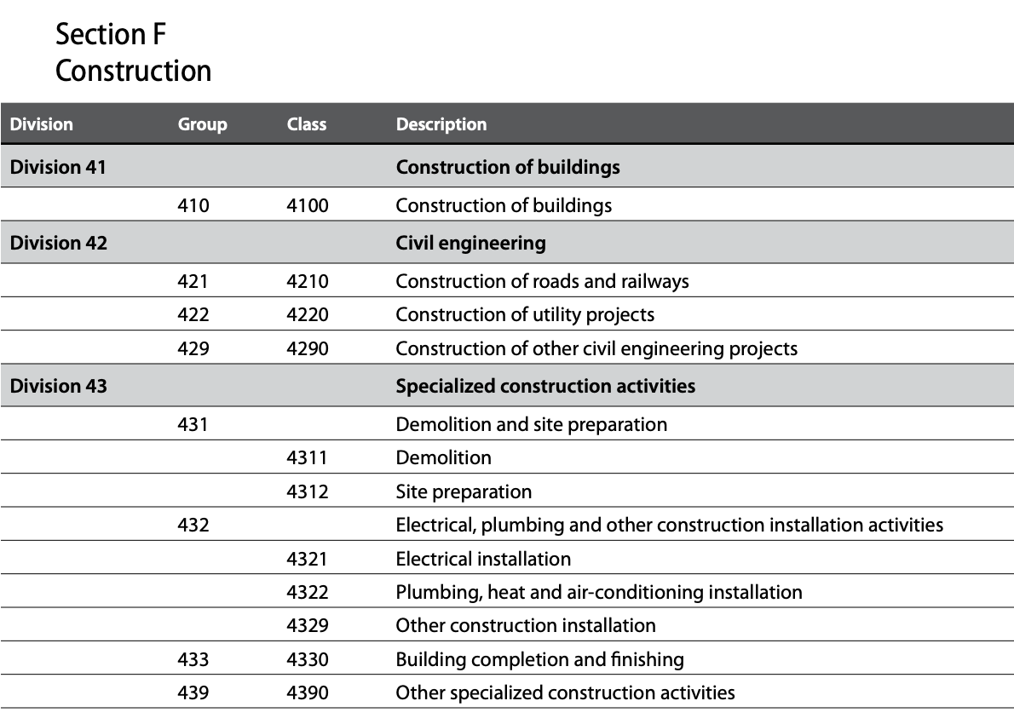

### ISIC sections

Division numbers are in brackets, with 2023 revisions in ***bold/italics***.

**Code Economic Area**

A Agriculture, Forestry and Fishing (01-03)

B Mining and Quarrying (05-09)

C Manufacturing (10-33)

D Electricity, Gas, Steam and Air Conditioning Supply (35)

E Water Supply; Sewerage, Waste Management and Remediation Activities (36-39)

F Construction (41-43)

***G Wholesale and Retail Trade; Repair of Motor Vehicles and Motorcycles (46-47)***

* *Structure is being simplified to just Wholesale and Retail Trade*

H Transportation and Storage (49-53)

I Accommodation and Food Service Activities (55-56)

***J Information and Communication (58-63)***

* *Being modernised to reflect developments since the 2000s*

***K Financial and Insurance Activities (64-66)***

* *Some adjustments to reflect innovations.*
* *However, the proposal of creating new Fintech division was rejected because in the ‘majority of the cases these are not actually new activities, just being provided via a new modality.’*

L Real Estate Activities (68)

M Professional, Scientific and Technical Activities (69-75)

N Administrative and Support Service Activities (77-82)

O Public Administration and Defence; Compulsory Social Security (84)

***P Education (85)***

* *Restructuring*

Q Human Health and Social Work Activities (86-88)

***R Arts, Entertainment and Recreation (90-93)***

* *Minor tweaks and being renamed ‘Arts, Sports and Recreation’*

S Other Service Activities (94-96)

T Activities of Households as Employers; Undifferentiated Goods and Services Producing Activities of Households for Own Use (97-98)

U Activities of Extraterritorial Organisations and Bodies (99)

### Recent ISIC policy decisions

In the recent ISIC revision discussions, there were debates about

* Whether to create a new single section or division for ‘intermediation services’ (i.e. platforms) but the decision was taken instead to create new groups or classes for this within the existing divisions - see [slide 12 in this September 2022 deck](https://unece.org/sites/default/files/2022-09/S_1_1_UNSD%20and%20Eurostat.pdf).
* Whether to make revisions for
  + Factoryless goods producers
  + “Activities related to climate change mitigation and conservation, management and restoration of ecosystems and biodiversity; activities related to electric cars (including manufacture, charging stations, etc.); and the classification of biofuels”
* However, it was decided that changes were not required other than in the explanatory notes - see [slide 14](https://unece.org/sites/default/files/2022-09/S_1_1_UNSD%20and%20Eurostat.pdf) in the above deck.

### Alternative ISIC aggregations for the information economy

There are two recommended aggregations of ISIC classes and groups from different sections and divisions:

* ICT sector
  + ICT manufacturing industries - from division 26
  + ICT trade industries - from division 46
  + ICT services industries - from divisions 58, 61, 62, 63 and 95
* Content and media sector
  + Publishing - from division 58
  + Films / TV / audio - from division 59
  + Broadcasting - from division 60
  + Others - from division 63

### Other ISIC-related classifications

There are several others maintained by UNSTAT which have relationships with ISIC and NACE:

* COFOG - Classifications of the Functions of Government
* ISCO - International Standard Classification of Occupations
* ISCED - International Standard Classification of Education
* Tourism Satellite Account (TSA)

We have already incorporated COFOG into noslegal’s Legal Perspectives facet.

### 

### NACE

* This is the EU’s taxonomy
  + The original version (1961) was known as NICE but became NACE in 1970
  + In the 1980s, NACE was aligned with the ISIC 1st and 2nd levels
  + NACE Rev 1 was published in 1990, based on ISIC Rev 3
  + Rev 1.1 followed in 2002, based on ISIC Rev 3.1
  + Rev 2 was prepared in 2006, based on ISIC Rev 4
* [NACE Rev 2.1](https://ec.europa.eu/eurostat/web/products-eurostat-news/w/wdn-20230210-1) was published in February 2023 and is based on the latest revisions to ISIC.[5] It will be used officially in the EU from 2025.

### Structure of NACE

* The 1st and 2nd levels (section and division) are the same as ISIC.
* The 3rd and 4th levels have some differences, intended to ‘obtain a classification more suited to the structures of the European economies’ (para 121 of the [NACE Rev 2 manual](https://ec.europa.eu/eurostat/documents/3859598/5902521/KS-RA-07-015-EN.PDF)).
* However, groups and classes of NACE Rev. 2 can always be aggregated into the groups and classes of ISIC Rev. 4 from which they were derived.
* Some NACE numbers at levels 3 and 4 are different from those of ISIC at those levels. To reduce risk of confusion, NACE places a dot between the first two digits (division level) and the last two (groups and classes).
* For example:
  + Software publishing in ISIC is 582 (group) with a single class, 5820
  + In NACE software publishing is 58.2 (group) and has two classes - 58.21 (games) and 58.29 (other)

### National versions of NACE

* EU law allows member states to maintain national extensions of NACE
* The UK’s national taxonomy (UK SIC - last revised in 2007) is an example
* [UK SIC](https://assets.publishing.service.gov.uk/government/uploads/system/uploads/attachment_data/file/527619/SIC07_CH_condensed_list_en.csv/preview) follows NACE down to the fourth level but has some additional fifth level 5 digit codes. The numbering format is also different, e.g. 58.21 in NACE is 58210 in UK SIC.
* It is not yet clear whether UK SIC alignment with NACE will be maintained post-Brexit

### Examples of ISIC / NACE / UK SIC alignment

**ISIC Rev 4:**

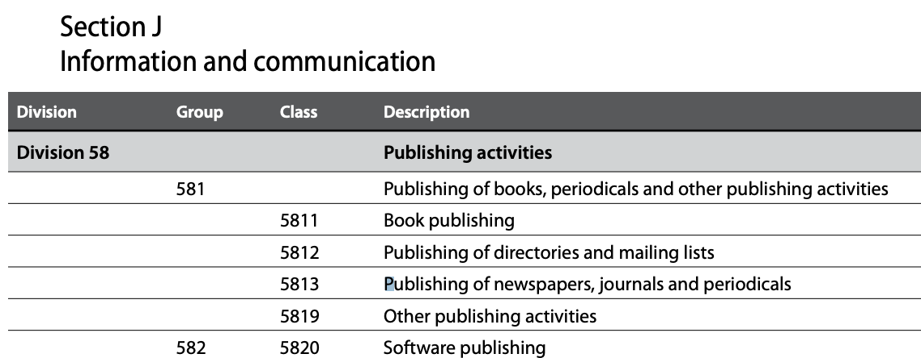

**NACE Rev 2:**

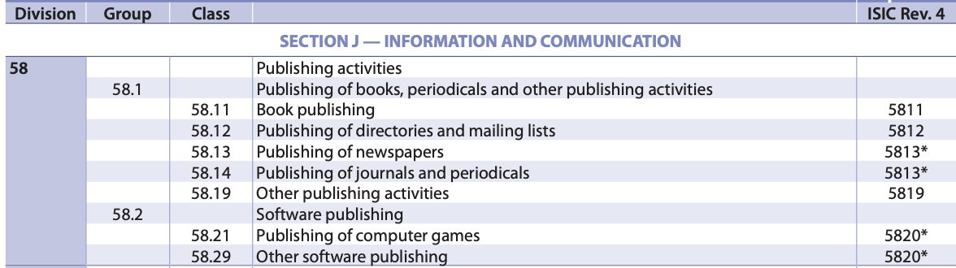

**UK SIC 2007:**

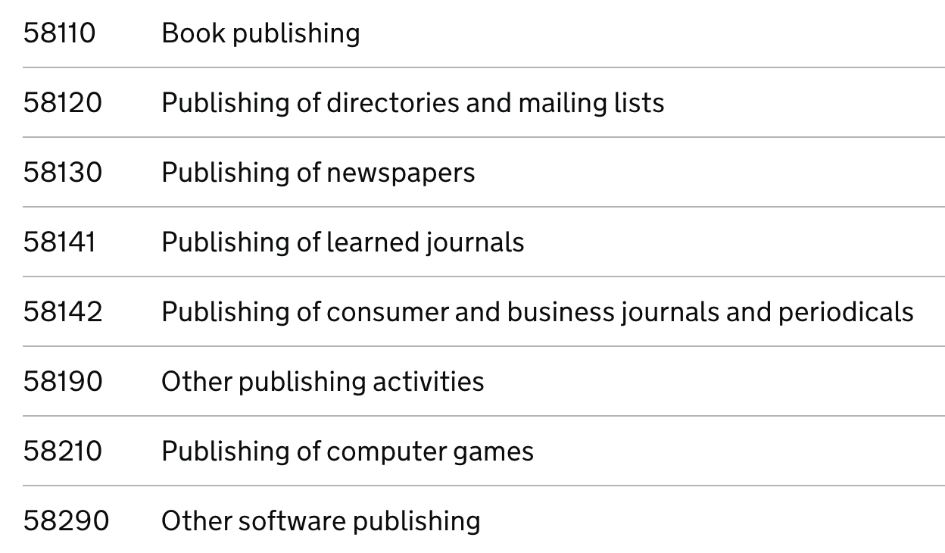

## The North American system: NAICS

### NAICS history

* The United States developed its own system called SIC, first published in 1937. SIC was last updated in 1987.
* In 1997, a replacement system called [NAICS](https://www.bls.gov/bls/naics.htm) was introduced by negotiation between the NAFTA member states, i.e. the US, Canada and Mexico. It has been revised every five years since 1997, mostly recently in 2022.
* NAICS is now used by the US Government generally, though the old SIC codes are still used by some official bodies (notably the SEC) and in various private sector US contexts. NAICS is not known to be used outside the US, Canada and Mexico.
* There are [concordance tables](https://www.census.gov/naics/?68967) to map NAICS to ISIC - this is a complicated exercise, as higher-level concepts map only roughly, and lower-level concepts largely do not map one-to-one, requiring notes to explain the differences.

### NAICS structure

NAICS departs more significantly than NACE from ISIC. At the highest level, NAICS has two large buckets (goods and services), each with second-level categories.

* Goods-Producing Industries
  + Natural Resources and Mining
  + Construction
  + Manufacturing
* Services-Producing Industries
  + Trade, Transportation and Utilities
  + Information
  + Financial Activities
  + Professional and Business Services
  + Education and Health Services
  + Leisure and Hospitality
  + Other Services (except Public Administration)
  + Public Administration

Only at NAICS’ third level does it start to map roughly to ISIC’s top level. The table seeks to summarise this at a high level. Grey shading indicates areas of high-level divergence. But at lower levels, there are many significant divergences.

| **NAICS 2022** | | **ISIC (2022 draft awaiting approval in 2023) sections and division range** | | **Notes** |
| --- | --- | --- | --- | --- |
| 11 | Agriculture, Forestry, Fishing and Hunting | A  01-03 | Agriculture, Forestry and Fishing | Roughly similar, but ISIC puts some activities (e.g. sawmilling, veterinary services) into other sections |
| 21 | Mining, Quarrying, and Oil and Gas Extraction | B  05-09 | Mining and Quarrying | Roughly similar, but ISIC puts some activities (e.g. site preparation) into other sections |
| 22 | Utilities | D 35 | Electricity, Gas, Steam and Air Conditioning Supply | Maps well, but NAICS is more detailed e.g. different types of renewables |
| E 36-39 | Water Supply; Sewerage, Waste Management and Remediation Activities (see below) | Major structural difference. Some differences of detail as well e.g. water pipelines in ISIC are in 49. |
| 23 | Construction | F 41-43 | Construction | Maps well, but NAICS is more detailed e.g. different types of buildings |
| 31-33 | Manufacturing | C 10-33 | Manufacturing | Maps well with minor exceptions (e.g. commercial printing) |
| 42 | Wholesale Trade | G 45-47 | Wholesale and Retail Trade | Maps well with minor exceptions (e.g. tombstone retailers) |
| 44-45 | Retail Trade |
| 48-49 | Transportation and Warehousing | H 49-53 | Transportation and Storage | Maps well with minor exceptions (e.g. vehicle repair) |
| 51 | Information | J 58-63 | Information and Communication | Maps well with some exceptions (e.g. library services) |
| 52 | Finance and Insurance | K 64-66 | Financial and Insurance Activities | Maps well |
| 53 | Real Estate and Rental and Leasing | L 68 | Real Estate Activities | Real estate aspects map well, but NAICS also includes renting of goods, which ISIC covers in section N |
| 54 | Professional, Scientific, and Technical Services | M 69-75 | Professional, Scientific and Technical Activities | Maps fairly well but some significant exceptions e.g. some computer-related services in NAICS which ISIC covers in section J instead |
| 55 | Management of Companies and Enterprises |  |  | Maps to groups in ISIC divisions 64 and 70 |
| 56 | Administrative and Support and Waste Management and Remediation Services | N 77-82 | Administrative and Support Service Activities  But note that ISIC includes Waste Management and Remediation Activities in section E - above | Maps in part, but major structural difference and some differences of detail |
| 61 | Educational Services | P 85 | Education | Maps well |
| 62 | Health Care and Social Assistance | Q  86-88 | Human Health and Social Work Activities | Maps well |
| 71 | Arts, Entertainment, and Recreation | R 90-93 | Arts, Sports and Recreation | Maps roughly, but NAICS covers agents, individual talent and reservation services here, whereas ISIC has them in divisions 33, 74 and 79 |
| 72 | Accommodation and Food Services | I 55-56 | Accommodation and Food Service Activities | Maps well |
| 81 | Other Services (except Public Administration) | S 94-96 | Other Services | Doesn’t map particularly well, as the definition of ‘other’ (i.e. What’s been left out elsewhere) is quite different between the two taxonomies |
| 92 | Public Administration | O 84 | Public Administration and Defence; Compulsory Social Security | Mostly maps well, but parts map into NACE 51 and 79 |
| U 99 | Activities of Extraterritorial Organisations and Bodies | ISIC 99 maps into parts of NAICS 92 |
|  |  | T 97-98 | Activities of Households as Employers; Undifferentiated Goods and Services Producing Activities of Households for Own Use | NAICS doesn’t cover this |

## Other systems

### Other major international standards

The NACE manual summarises other major international standards (CPC, SITC, BECs and HS). See below. ISIC, with its activity-focus, appears a more relevant starting point than the others for the purposes of legal work.

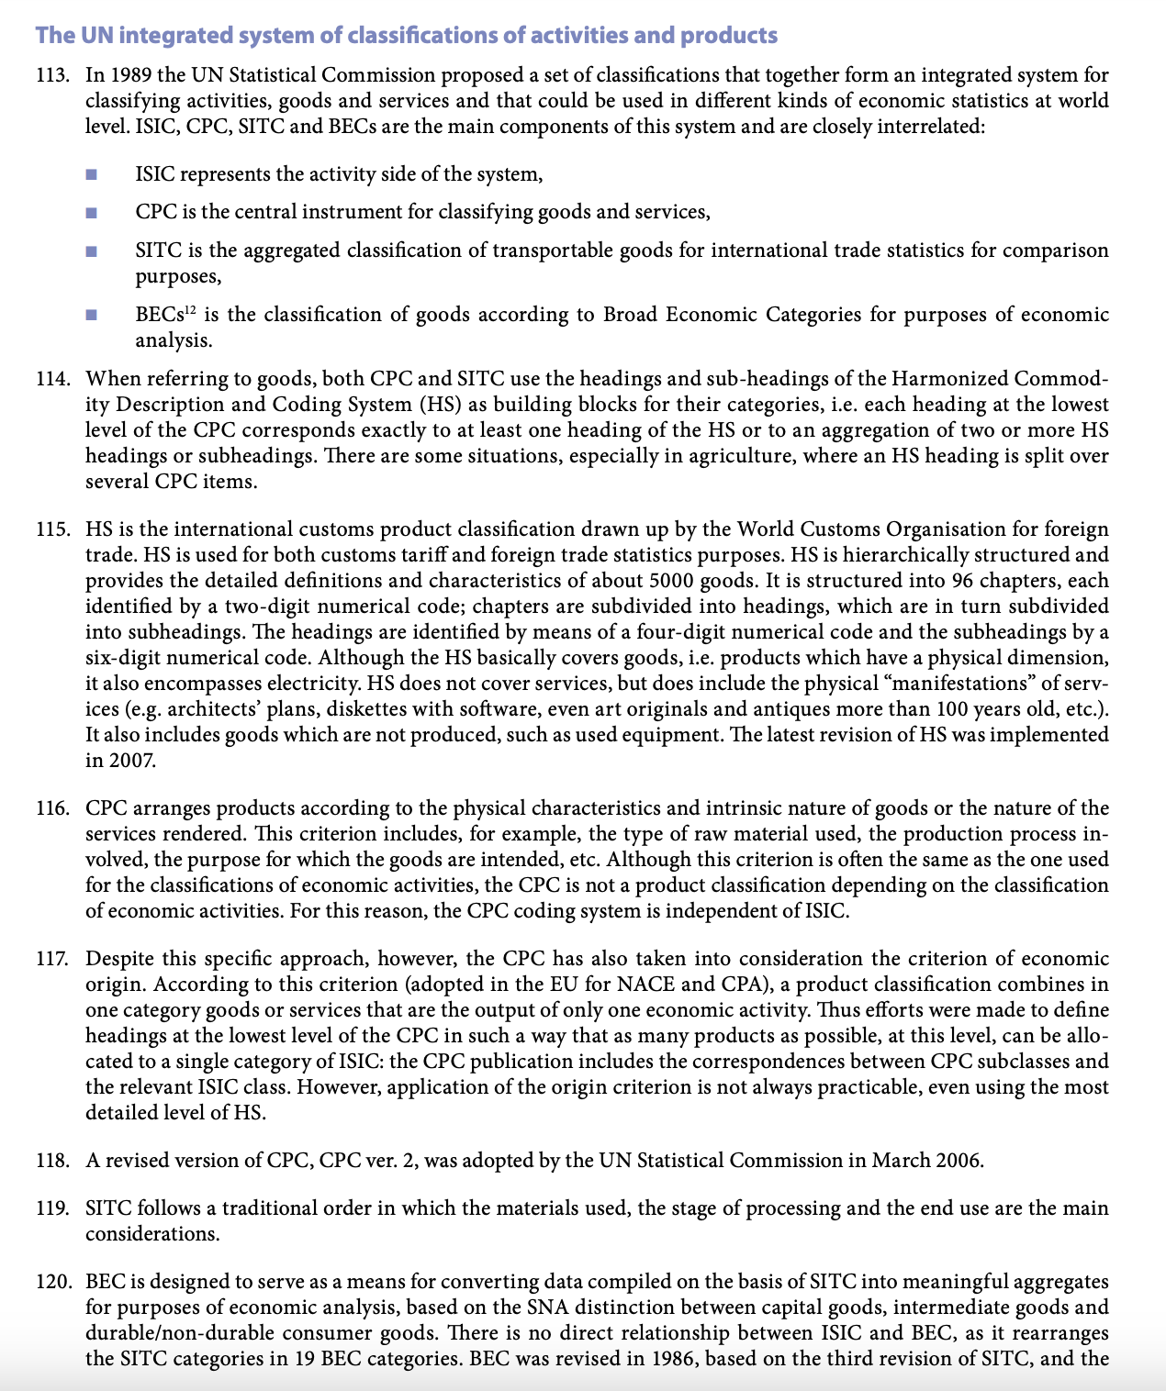

### Commercial standards

There are three major ones, each used as the basis of financial data products by the companies which own them:

* [GICS](https://www.msci.com/our-solutions/indexes/gics) - owned by MSCI / Standard & Poor’s
* [ICB](https://research.ftserussell.com/products/downloads/ICB_Rules_new.pdf) - owned by FTSE group
* [TRBC (Refinitiv)](https://www.refinitiv.com/en/financial-data/indices/trbc-business-classification) - owned by London Stock Exchange (bought from Blackstone / Thomson Reuters)

These do not seem a suitable choice:

* They have to be licensed for significant sums.
* We do not see any major advantage over NACE for legal work purposes.

### Other national standards

There are [various of these](https://en.wikipedia.org/wiki/Industry_classification#List_of_classifications) but none seems more compelling than NACE.

# 

# 

1. Primarily legal services providers (e.g. law firms or in-house legal departments), their customers and providers of technology for handling legal matters and related topics.
2. ALSPs are alternative legal services providers, typically corporates, or units within law firms, which take a more ‘process-driven’ approach to delivering types of law-related work for which such an approach can be more effective and efficient than traditional lawyering.
3. Organisations engaging with noslegal or adopting it should be invited to consider the existing synonyms and examples, and to contribute more.
4. The March 2022 release also had three top-level types. The March 2023 release renames (i) ‘People’ to ‘Persons’ to better reflect the non-individual nature of elements of it (ii) ‘Duties’ to ‘Obligations’ to reflect broad international legal usage (encompassing rights and liabilities) - the term is of Civil Law origin but used even in non-Civil Law countries as part of the taxonomy for mapping legal systems’ concepts to each other in private international law.
5. [See slide 26 of above deck](https://unece.org/sites/default/files/2022-09/S_1_1_UNSD%20and%20Eurostat.pdf)